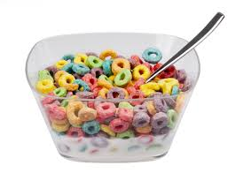NAME_____________________________________________ PERIOD_____

**COMPARING CEREALS**

**DIRECTIONS: You are to *compare 3 different* cereals. Using the cereal box labels complete the chart and answer the questions below. Base your answers on one serving without milk.**

|  |  |  |  |  |  |  |
| --- | --- | --- | --- | --- | --- | --- |
| **Cereal name** | **Serving**  **size** | **Main**  **Ingredient**  **(This is the first ingredient listed.)** | **Grams (g.)of fiber** | **Total grams (g.) of fat** | **Grams (g.) of sugar** | **Milligrams (mg.) of**  **Sodium (salt)** |
| 1 |  |  |  |  |  |  |
| 2 |  |  |  |  |  |  |
| 3 |  |  |  |  |  |  |

1. Which cereal has the most grams of fiber? (the higher the better)__________________
2. Which cereal has the least grams of fiber? _____________________________________
3. Which cereal has the most grams of fat?_______________________________________
4. Which cereal has the least grams of fat? (lower is better)__________________________
5. Which cereal has the most grams of sugar?_____________________________________
6. Which cereal has the least grams of sugar? (lower is better)_______________________
7. Which cereal has the most grams of sodium?___________________________________
8. Which cereal has the least grams of sodium?(lower is better) ______________________
9. Which cereal do you think is the most nutritious to eat?__________________________

Why?___________________________________________________________________

1. Which cereal do you think is the least nutritious to eat?__________________________

Why?__________________________________________________________________

1. Of all the cereals in the supermarket, what cereal is your favorite?_________________